CPS470: Computer Networks and Security
Written Homework 1
Grant Harvey
Total Points: 100

Note: In all written assignments, please show as much of your work as you can. Even if you get a wrong answer, you can get partial credit if you show your work. If you make a mistake, it will also help the grader show you where you made a mistake. You can either type your answers in the solution area and submit the file directly on Isidore or hand-write your answers and get a scanned version of it to submit on Isidore. If you find the default space is not sufficient for you to type/handwrite your answers, please feel free to enlarge the space as needed. Please make sure your handwriting is clear and understandable. If the grader or I cannot understand your handwriting, you get zero for your solutions.

Problem 1. [20 points] Give an example of a human protocol that takes place between you and your parents/guardians or you and your siblings (other than any protocol discussed in the slides of the Introduction Chapter). What messages are exchanged? What are the message formats, and what is the order of message exchange? What actions are taken by each protocol entity on the transmission and/or receipt of a message?

Solution:

Human Protocol Example:
Entities = Me (Child) and Mom (Parent)
Purpose of protocol = determine evening Meal

Message Exchange and Order

- Me: “Hey Mom, What's for Dinner?”
  - Format = question requesting meal information
  - Action Initiated = initiate protocol
- Mom: “Glad you asked, we are having Taco Tuesday”
  - Format = verbal response with meal details
  - Action Initiated = child learns about planned meal
- Me: “Heck Yeah! I love Taco Tuesday!”
  - Format = verbal approval
  - Action Initiated = parent confirms approval and continues with making meal
- Both: Eat Tacos
  - Format = all users eat physical meal after step 3 is finished
  - Action Initiated = eat dinner together

Messages start with me, the son, starting the protocol by asking what's for dinner. My mom then sends a message back with what we are having that day, I then respond with my thoughts on that meal, and lastly we eat the meal provided together.

Problem 2. [20 points] Consider the figure below, with three links, each with the specified transmission rate and link length.
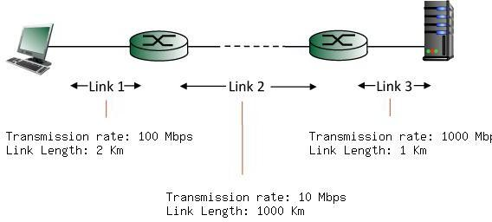

Find the end-to-end delay (including the transmission delays and propagation delays on each of the three links, but ignoring queueing delays and processing delays) from when the left host begins transmitting the first bit of a packet to the time when the last bit of that packet is received at the server at the right. The speed of light propagation delay on each link is 3x10^8 m/sec. Note that the transmission rates are in Mbps and the link distances are in Km. Assume a packet length of 4000 bits. Give your answer in milliseconds.

Solution:

Link 1:
100 Mbps == 100,000,000 bps
2 km == 2,000 m
d-trans == L/R == 4,000 bits / 100,000,000 bps == 0.00004 s
d-prop == d/s == 2,000 m / 3x10^8 m/sec == 0.000006667 s
d-trans + d-prop == 0.000046667 s == 0.046667 ms

Link 2:
10 Mbps == 10,000,000 bps
2000 km == 2,000,000 m
d-trans == L/R == 4000 bits / 10,000,000 bps == 0.0004 s
d-prop == d/s == 2,000,000 m / 3x10^8 m/sec == 0.006667 s
d-trans + d-prop == 0.007067 s == 7.067 ms

Link 3:
1000 Mbps == 1,000,000,000 bps
1 km == 1000 m
d-trans == L/R == 4000 bits / 1,000,000,000 bps == 0.000004 s
d-prop == d/s == 1000 m / 3x10^8 m/sec == 0.000003333 s
d-trans + d-prop == 0.000007333 s == 0.007333 ms

Total == 0.046667 ms + 7.067 ms + 0.007333 ms == 7.121 ms

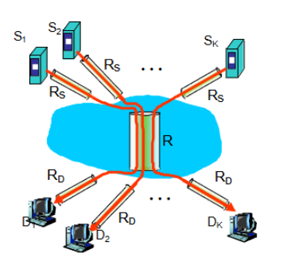
Problem 3. [20 points] Consider the network scenario in the figure below. K sources are connected to the Internet via links of capacity R_{S}, and within the network fairly share a common link of capacity R, to K destinations. Each destination is connected to the network by a link of capacity R_{D}. You can assume that there are no other links or source-destination pairs in the network.
Suppose that source S_{i} has an infinitely large file it wants to send to destination D_{i} (i.e., each source sends to a different destination).

- Suppose that K=10, R_{S} = 100 Mbs, R_{D}= 54 Mbs, and R = 50 Gbs. What is the throughput between each source-destination pair? Where are the bottleneck links?
- Suppose now that K=10, R_{S} = 100 Mbs, R_{D}= 1 Mbs, and R = 0.75 Gbs. What are the throughputs between each source-destination pair? Where are the bottleneck links?
- In scenario 2 above, suppose we increase the capacity of the destination links to 100 Mbps. Will this increase the throughput between sources and destinations? Explain your answer.
- Now repeat 1 above, but assume that the link connecting S₁ to the network has a capacity of 1 Mbps, and that all other values are unchanged.

Solution:

Throughput = min(R_{S}, R_{D}, R/K)
K == 10
1.
R == 50 Gbs == 50,000 Mbs
R/K == 50,000 Mbs / 10 == 5,000 Mbs
Throughput == min(100 Mbs , 54 Mbs, 5000 Mbs) == 54 Mbs – R_{D}, the destination link, is the bottleneck

2.
R == 0.75 Gbs == 750 Mbs
R/K == 750 Mbs / 10 == 75 Mbs
Throughput == min(100 Mbs, 1Mbs, 75 Mbs) == 1 Mbs – R_{D}, the destination link, is the bottleneck

3.
Throughput == min(100 Mbs, 100 Mbs, 75 Mbs) = 75 Mbs – R, the Link Capacity becomes the new bottleneck. This happens because when we change the destination link from 1 Mbs to 100 Mbs, it is no longer the smallest transfer number, which is now the lank capacity. And you can’t transfer faster than your weakest tool.

4.
R == 50 Gbs == 50,000 Mbs
R/K == 50,000 Mbs / 10 == 5,000 Mbs
Throughput == min(1 Mbs, 54 Mbs, 5000 Mbs) == 1 Mbs – S₁ is the new bottleneck. This happens because S₁’s throughput is limited to 1 Mbs by its source link, all the other sources will maintain the normal 54 Mbs since everything else is unaffected.

Problem 4. [20 points] Due to the security reason, you cannot use traceroute program successfully if you are using UD network. Therefore, regarding this problem, let’s perform a traceroute using an online traceroute to cs.ucla.edu at three different times of day. The website is https://www.site24x7.com/tools/trace-route.html (Please select your location as Columbus-US when testing as shown in the following figure)

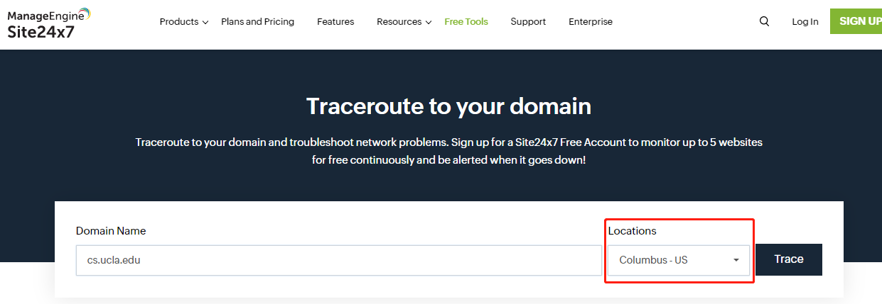

(Cut and Paste the output from your traceroute into your assignment).

  - For each of the three times of day, what is the average of the RTT delay (i.e., the response time shown in the traceroute result) from a machine somewhere Columbus to cs.ucla.edu?
  - How many routers are in the path at each time of day? Did the set of routers or the number of routers ever change?
  - For one of your times of day, can you identify an ISP in the path from source to destination. For example, if you specify Domain Name as udayton.edu when playing with the traceroute website, you may find that the 4th hop is
lag-111.bear2.Cincinnati1.Level3.net (4.59.40.13). Then, if you use whois program to check that hop’s IP (i.e., 4.59.40.13), you will find that this hop is from an organization called Level 3 Parent, LLC. And if you google this organization’s name, you will find that Level 3 Parent, LLC is an ISP. (Note: not all the hops/routers on the routing path are from the ISP)
Regarding this subproblem, there's no right or wrong answer here - just see what you can find about one or more of the ISPs that you find in one of your traceroutes. You will also find the online whois is very easy to use, and you can try whois in the following website directly: https://who.is/
  - Repeat steps 1 and 2 for www.tsinghua.edu.cn, the web page for a university in Beijing, China. Here, you do NOT need to include the traceroute output in your assignment. Just the numerical answers.

Solution:

2026/01/27 – 9:40 PM – Traceroute 1
traceroute to cs.ucla.edu (164.67.100.182), 30 hops max, 40 byte packets
1 64-79-69-73.xlhdns.com (64.79.69.73) 0.397 ms * 0.634 ms
2 vl2515.core1-pe5.xlhost.com (206.222.27.137) 0.197 ms 0.425 ms 0.440 ms
3 omega-core1.xlhost.com (206.222.27.34) 1.087 ms 1.094 ms 1.097 ms
4 ae52.bar1.Cleveland1.Level3.net (4.53.198.57) 3.005 ms 3.016 ms 3.237 ms
5 * * *
6 CENIC.ear1.LosAngeles1.Level3.net (4.35.156.66) 59.525 ms 59.585 ms 59.530 ms
7 losa4-agg-01--lax-agg10--400g--01.cenic.net (137.164.11.111) 59.613 ms 59.833 ms 59.836 ms
8 * * *
9 bd10f1.anderson--cr00f2.csb1.ucla.net (169.232.4.4) 59.870 ms 59.876 ms 59.925 ms
10 cr10f2.csb1--dr10f1.anderson.ucla.net (169.232.4.57) 60.078 ms 59.907 ms 59.934 ms
11 * * *
12 * * *
13 seasweb02.seas.ucla.edu (164.67.100.182) 60.010 ms 60.006 ms 59.994 ms

Questions for Traceroute 1:
- (60.010 ms + 60.006 ms + 59.994 ms) / 3 = 60.003 ms average
- 12 routers since its 13 hops and subtract one
- ae52.bar1.Cleveland1.Level3.net is for “Level 3 Communications LLC” on a quick google search they are also shown to be an ISP

2026/01/28 – 12:12 PM – Traceroute 2
traceroute to cs.ucla.edu (164.67.100.182), 30 hops max, 40 byte packets
1 64-79-69-225.xlhdns.com (64.79.69.225) 0.404 ms * 0.530 ms
2 vl2620.core2-pe10.xlhost.com (206.222.27.85) 0.341 ms 0.499 ms 0.511 ms
3 omega-core2.xlhost.com (206.222.27.38) 0.922 ms 1.022 ms 1.085 ms
4 ae52.bar1.Cleveland1.Level3.net (4.53.198.57) 16.253 ms 16.301 ms 16.314 ms
5 * * *
6 CENIC.ear1.LosAngeles1.Level3.net (4.35.156.66) 59.435 ms 59.381 ms 59.416 ms
7 losa4-agg-01--lax-agg10--400g--01.cenic.net (137.164.11.111) 60.096 ms 60.131 ms 60.146 ms
8 * * *
9 bd10f1.anderson--cr00f2.csb1.ucla.net (169.232.4.4) 60.023 ms 60.036 ms 60.029 ms
10 cr10f2.csb1--dr10f1.anderson.ucla.net (169.232.4.57) 60.415 ms 60.368 ms 60.370 ms
11 * * *
12 * * *
13 seasweb02.seas.ucla.edu (164.67.100.182) 59.950 ms 59.903 ms 59.891 ms

Questions for Traceroute 2:
- (59.950 ms + 59.903 ms + 59.891 ms) / 3 = 59.915 ms average
- 12 routers since its 13 hops and subtract one
- www.tsinghua.edu.cn Website Results:
(245.367 ms + 245.427 ms + 245.185 ms) / 3 = 245.326 ms average
22 Routers since its 23 hops subtract one

2026/01/28 – 01:38 PM – Traceroute 3
traceroute to cs.ucla.edu (164.67.100.182), 30 hops max, 40 byte packets
1 38.89.70.1 (38.89.70.1) 0.226 ms * 0.206 ms
2 0.ae50.er1.sea3.us.zip.zayo.com (216.200.241.73) 0.453 ms 0.496 ms 0.494 ms
3 * * *
4 * * *
5 * * *
6 * * *
7 * * *
8 * * *
9 dc-snvl2-agg-01--svl-agg10-400g.cenic.net (137.164.11.81) 27.582 ms 27.568 ms 27.565 ms
10 losa4-agg-01--snvl2-agg-01--800g--2.cenic.net (137.164.11.20) 27.490 ms 27.607 ms 27.604 ms
11 * * *
12 bd10f1.anderson--cr00f2.csb1.ucla.net (169.232.4.4) 27.861 ms 27.858 ms 27.856 ms
13 cr10f2.csb1--dr10f1.anderson.ucla.net (169.232.4.57) 27.883 ms 27.877 ms 28.121 ms
14 * * *
15 * * *
16 seasweb02.seas.ucla.edu (164.67.100.182) 27.596 ms 27.586 ms 27.578 ms

Questions for Traceroute 3:
- (27.596 ms + 27.586 ms + 27.578 ms) / 3 = 27.587 ms average
- 15 routers since its 16 hops and subtract one
- www.tsinghua.edu.cn Website Results:
(179.424 ms + 179.520 ms + 179.686 ms) / 3 = 179.543 ms average
19 Routers since its 20 hops subtract one

Overall Answers and observations:
The routers and average RTT delay did not significantly change for me when going to the UCLA website, however it shot up in both delay and routers for the website in China. This shows that as one might think, the farther away a website is located the larger the RTT delay and the more routers it will have to pass through. The average RTT to the Chinese destination decreased from approximately 245 ms in one measurement to about 179 ms in a later measurement. This variation is likely due to changes in routing paths and network congestion. Overall, these results show that longer geographic distances generally lead to higher RTTs and more hops, while dynamic Internet routing can cause RTTs to fluctuate over time.

Problem 5. [20 points] Consider a sensing application, where each sensor generates 1000 bits of information one per minute, and then sends that data to a server. Thus, most of the time, the sensor has nothing to send (having only to send 1 update per minute on average).

- Would a circuit-switching or packet-switching network work well for this application? Why?
Its 1000 bits a minute or 1000 b / 60 s = 16.7~ bps which is extremely low and it will be idle most of the time. It also does not mention any strict delay or requirements that stop us from sending the data whenever we can. For all those reasons I would say Packet Switching is better. Packet switching is best for bursty data which is exactly what this is.

- Now suppose that the application changes from sensing to remote neurosurgery, where remote surgeons are collaborating on an operation in which each is operating a different medical device at the central server, and seeing a video of the operation. Again, we focus on the only network from remote surgeons to the central server and similarly again assume that each surgeon may generate an action (resulting in a fixed- length 1000-bit update message being sent to a central server) once every minute on average. Most of the time, however, a surgeon does not send an update since s/he is taking some local action (e.g., inspecting the return video which is rendered locally). Does your answer to 1 above change? Why?
Yes, my answer does change. It seems like under this new direction we need the data almost instantly when it is sent to make sure everything is safe. Because of that, we can't have it possibly getting stuck in a queue or competing with other traffic if other applications sent through data. We need to be able to send data whenever with no slowdown. So I would change it to circuit switching.

